**AWS ->**

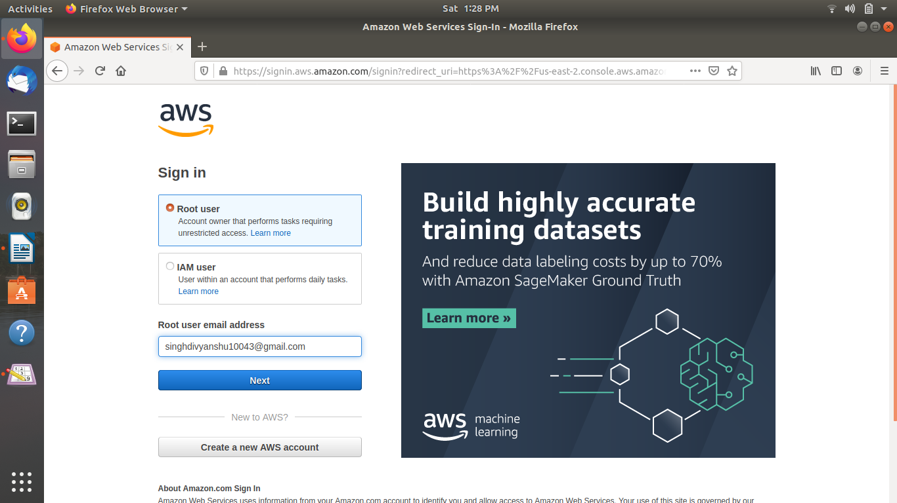1. AWS Login screen with username ->

2. EC2 Dashboard ->

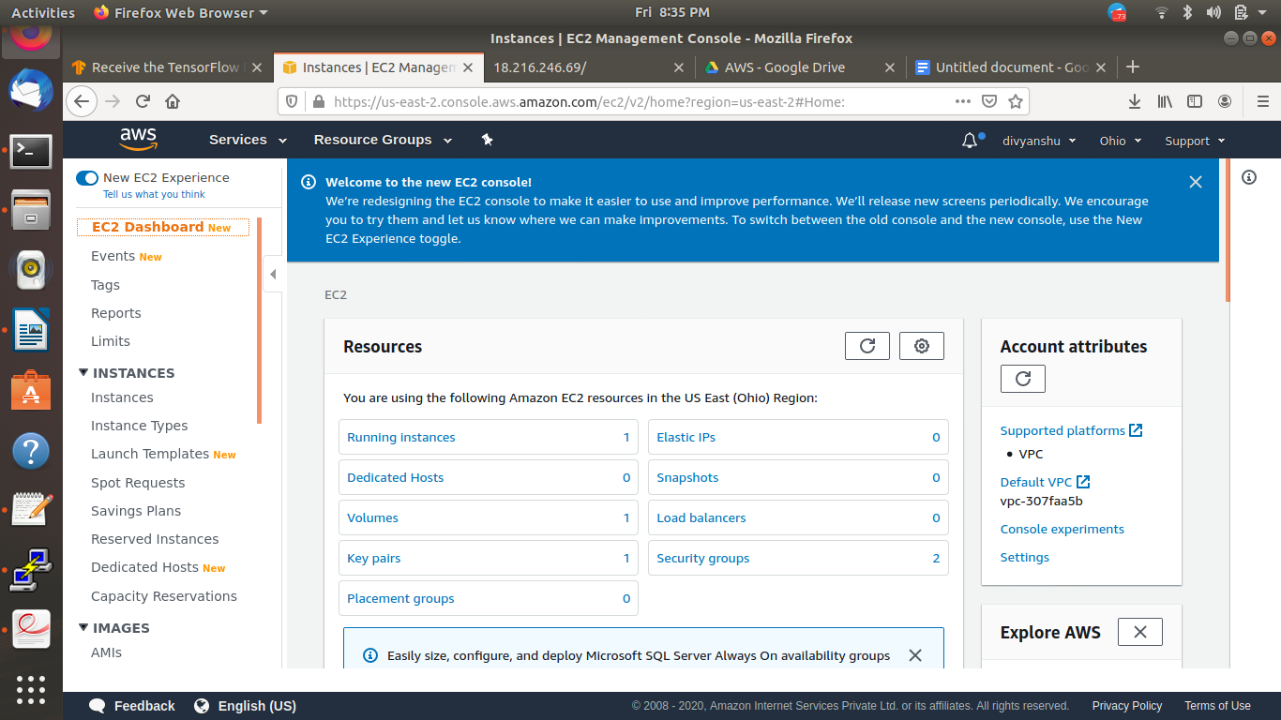

3. S3 Dashboard ->

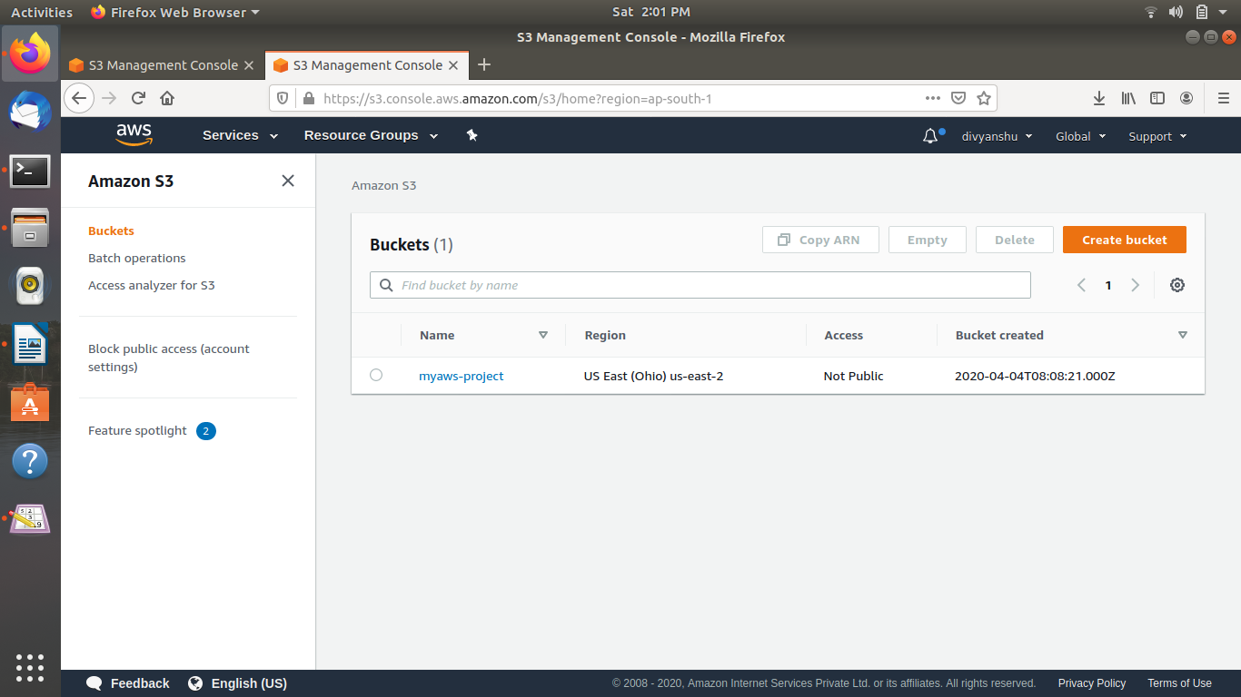

4. Rekognition Dashboard ->

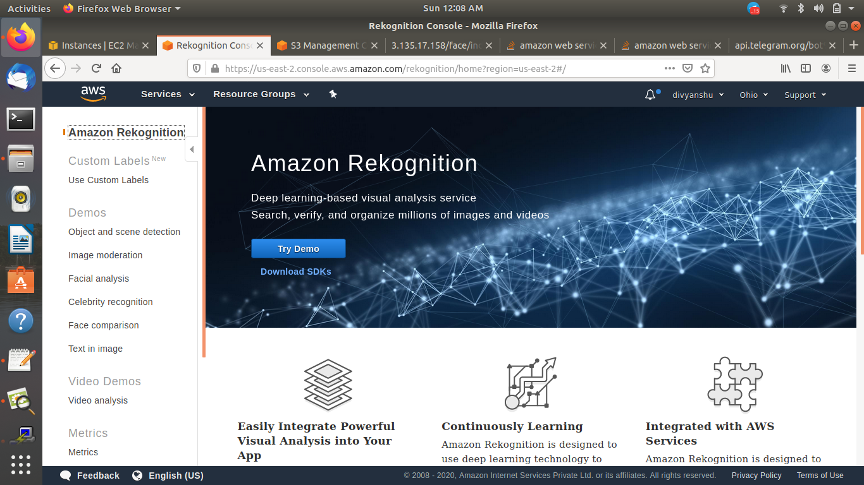

**EC2 ->**

1. Choosing an AMI ->

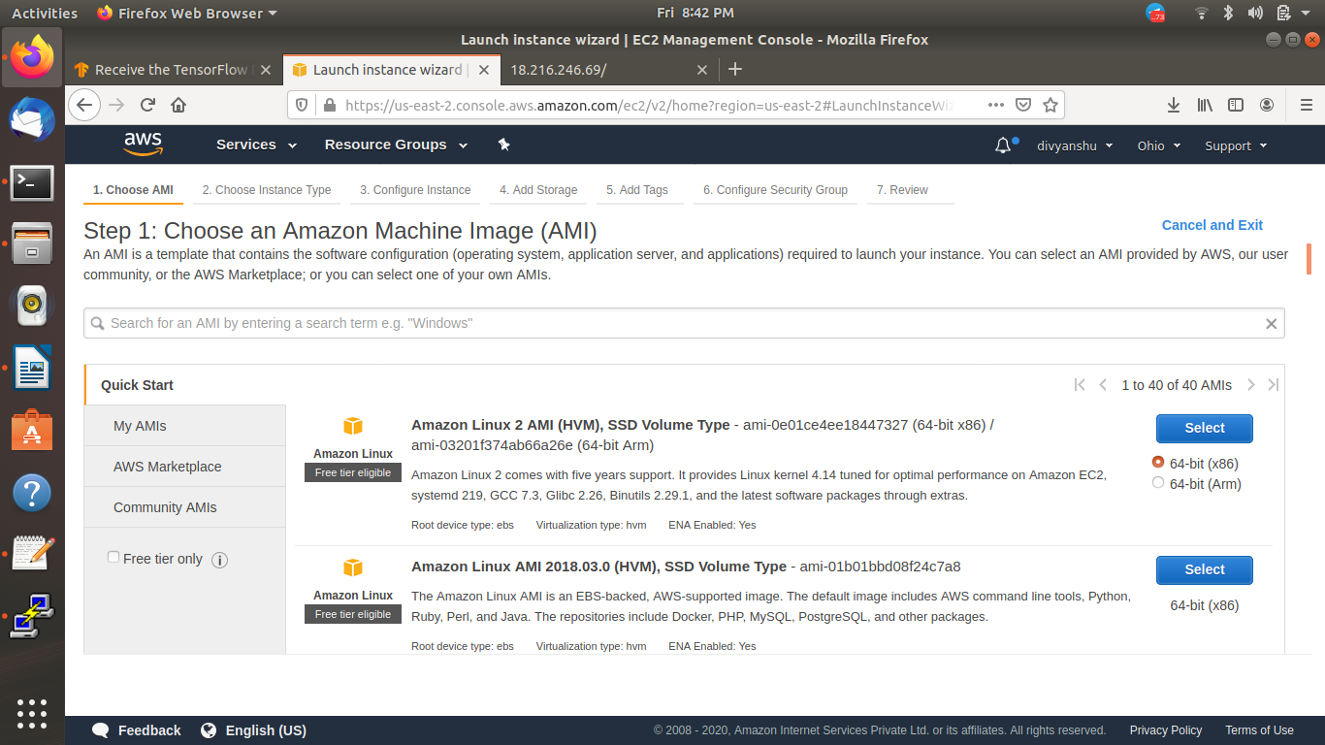

2. Choosing an Instance Type ->

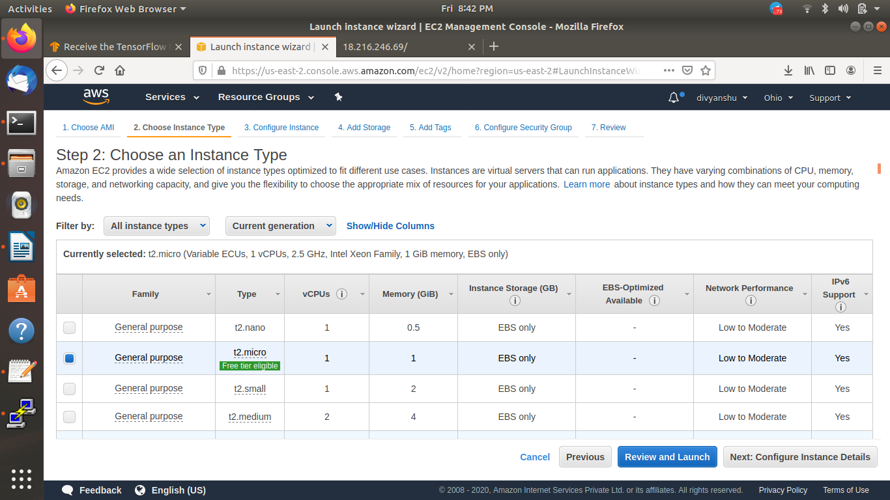

3. Adding Storage ->

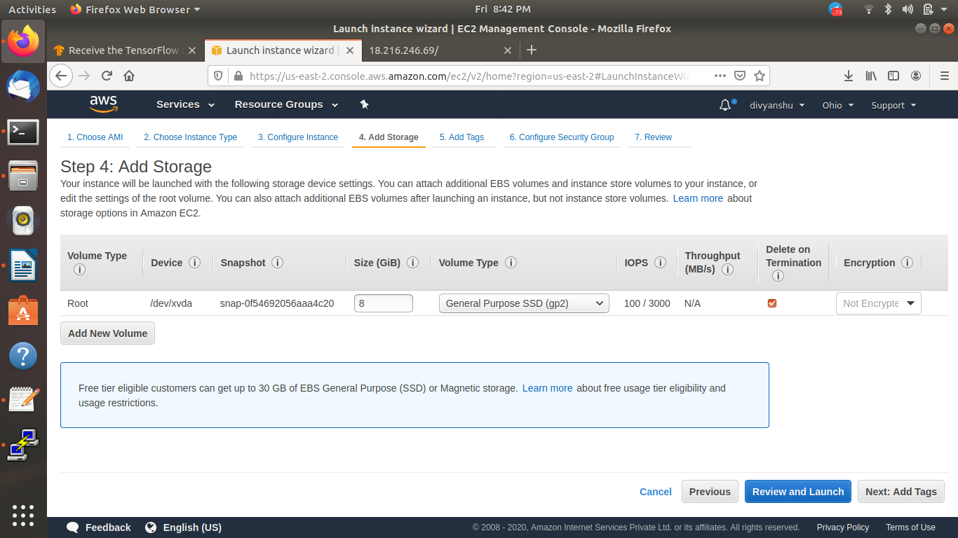

4. Configuring Security Group ->

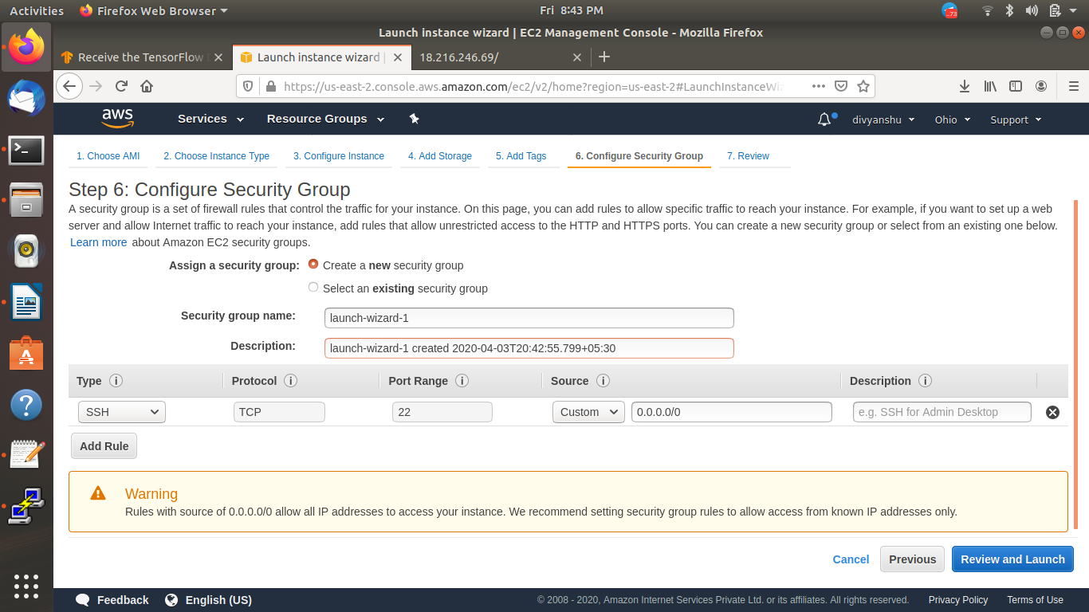

5. Key Pair Download ->

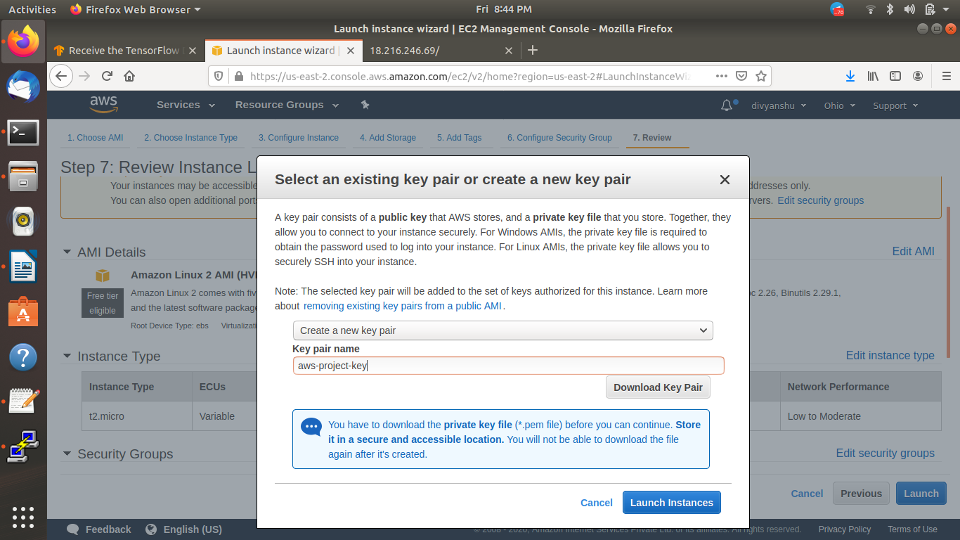

6. PuTTYgen conversion from pem to ppk ->

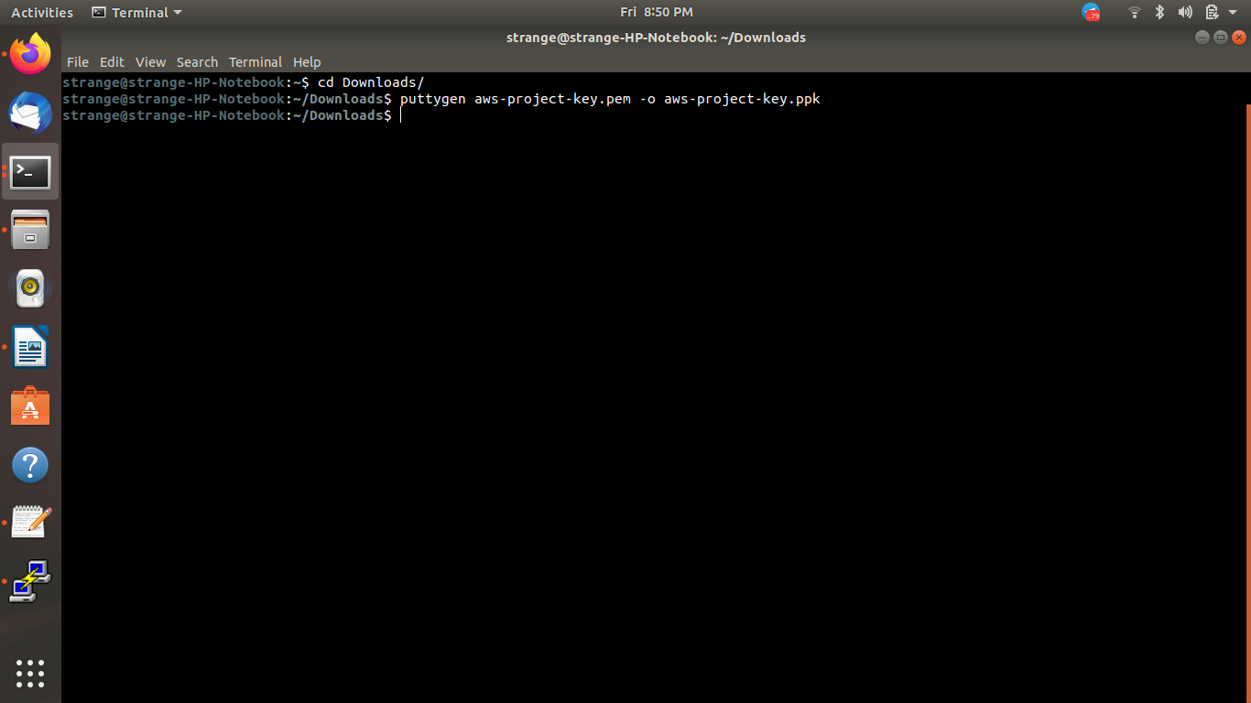

7. Logged in EC2 black screen ->

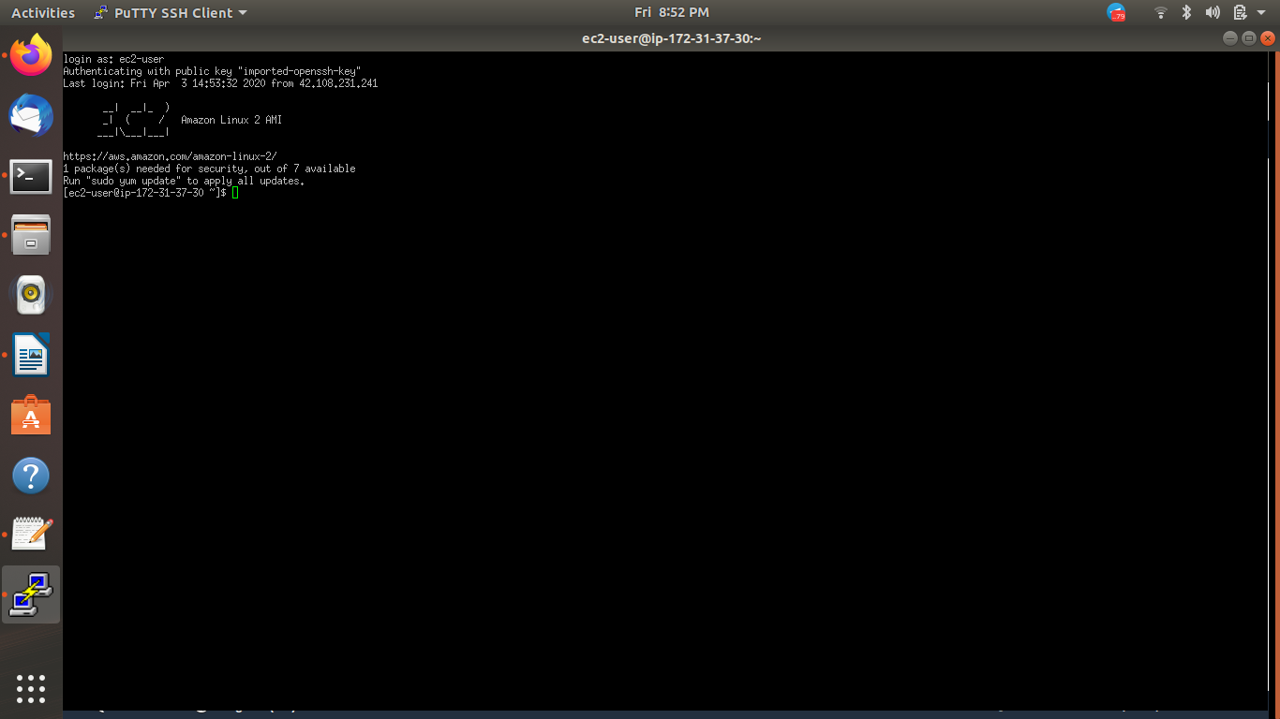

**S3 ->**

1. Creating a bucket ->

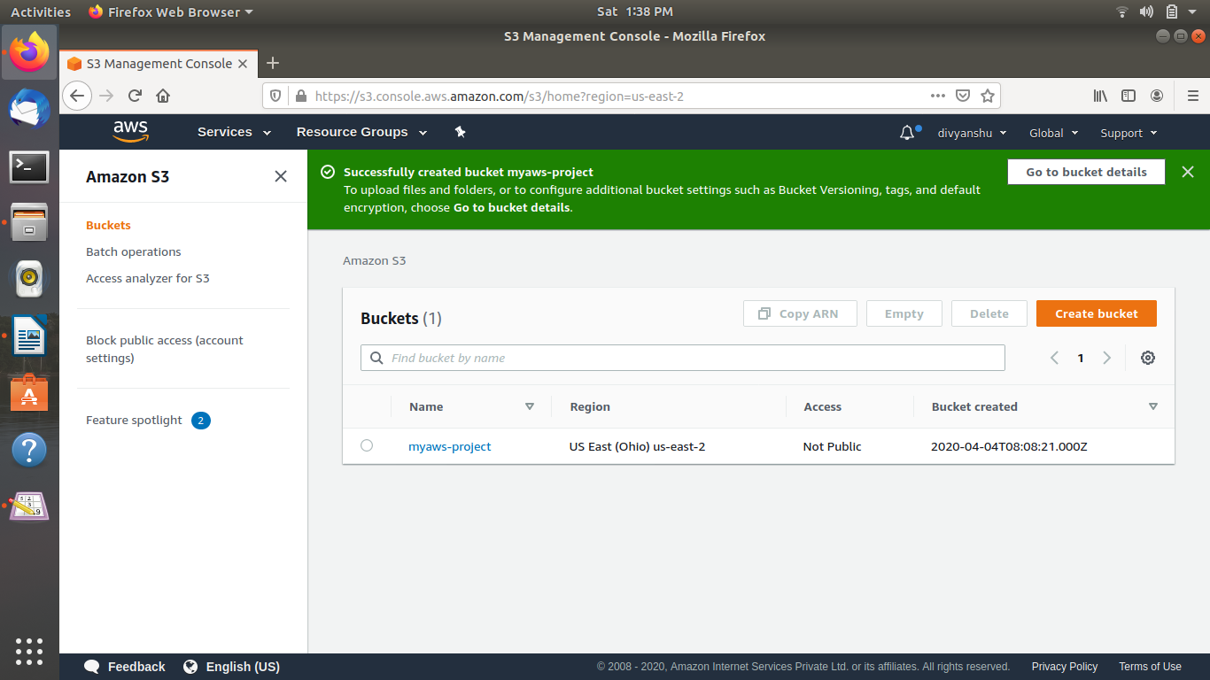

2. Uploading an Object ->

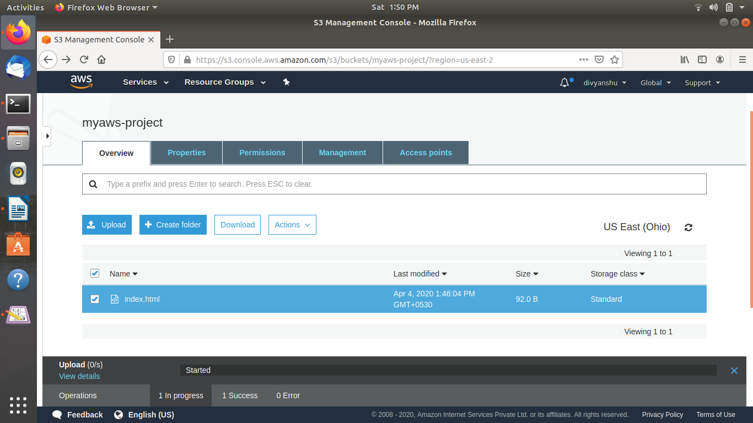

3. Enabling Static Website ->

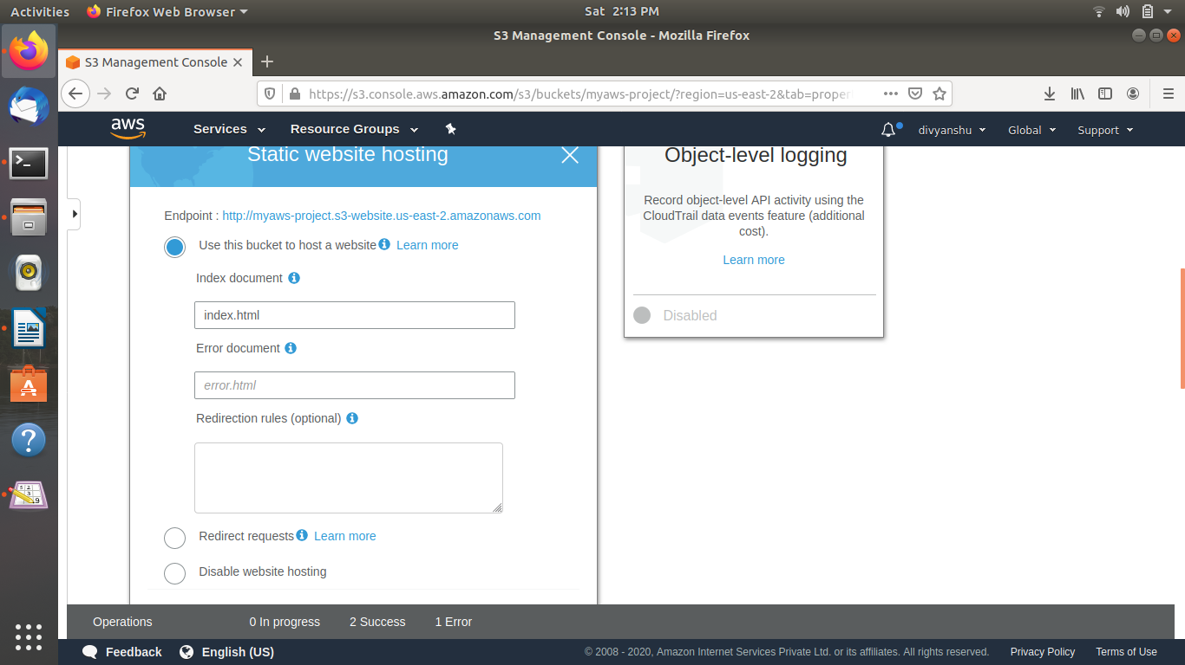

4. Making the Object Public ->

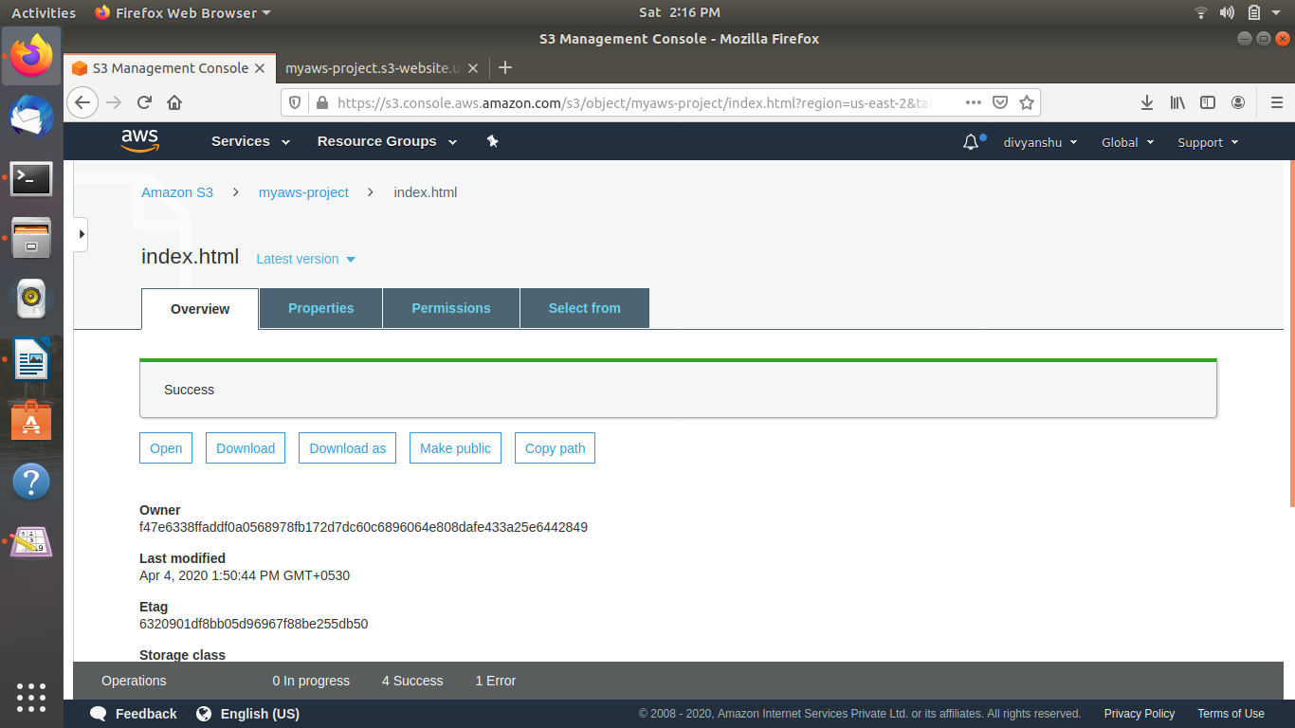

5. Checking the S3 link on the browser ->

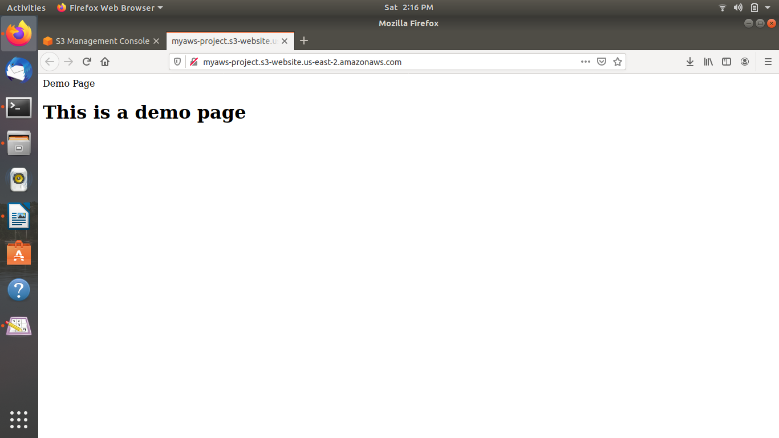

**Rekognition ->**

1. Face Detect ->

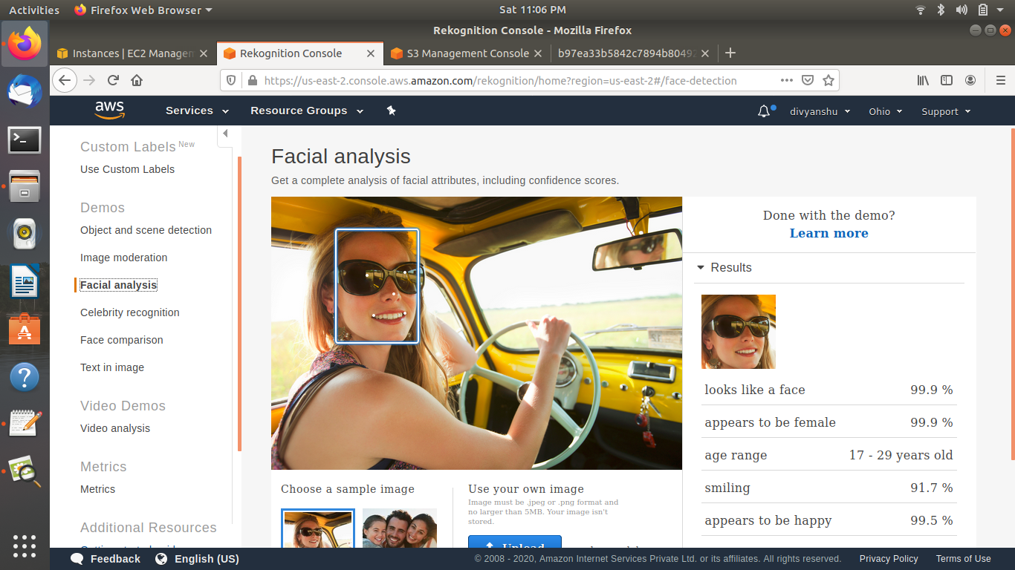

2. Face Compare ->

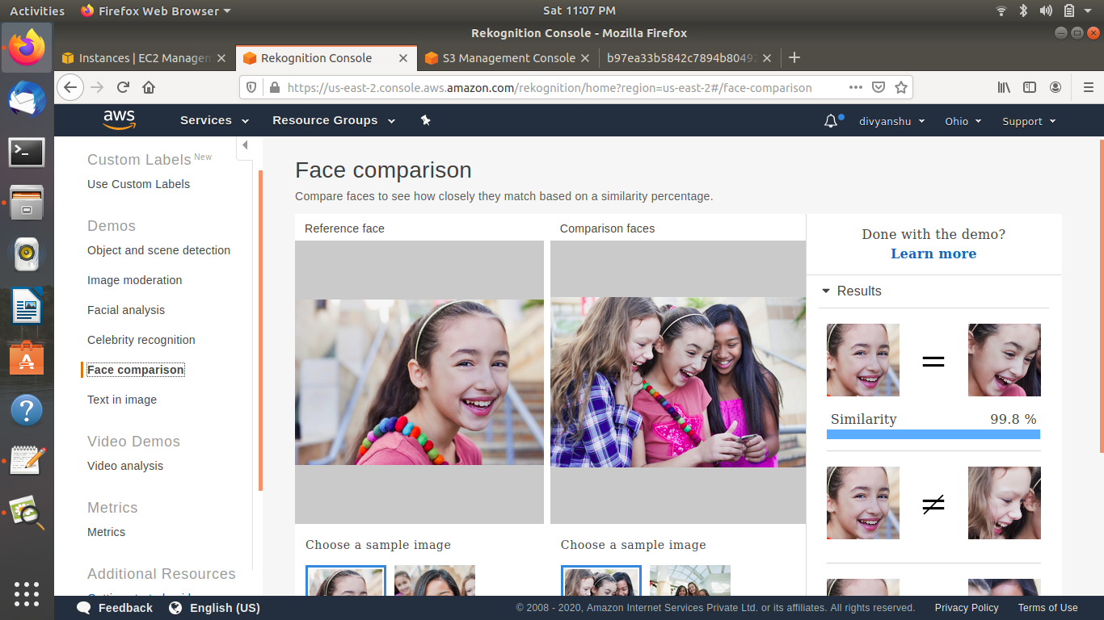

3. Celebrity Recognition ->

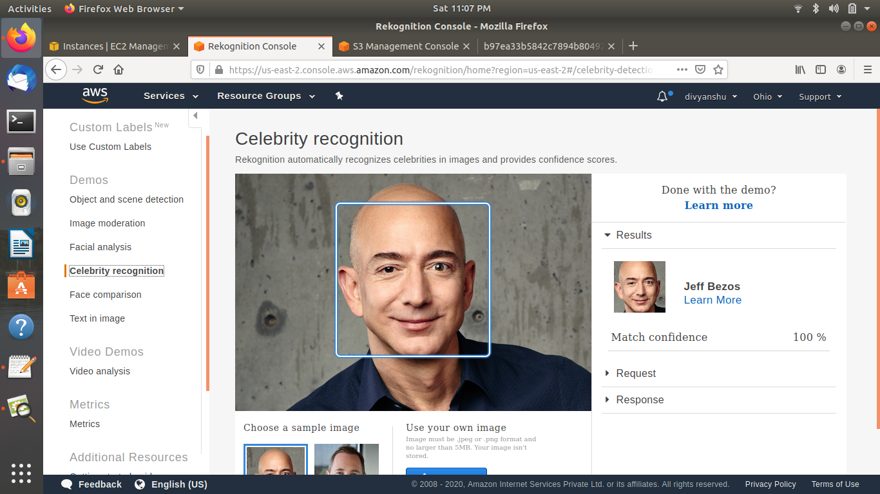

4. Text in Image ->

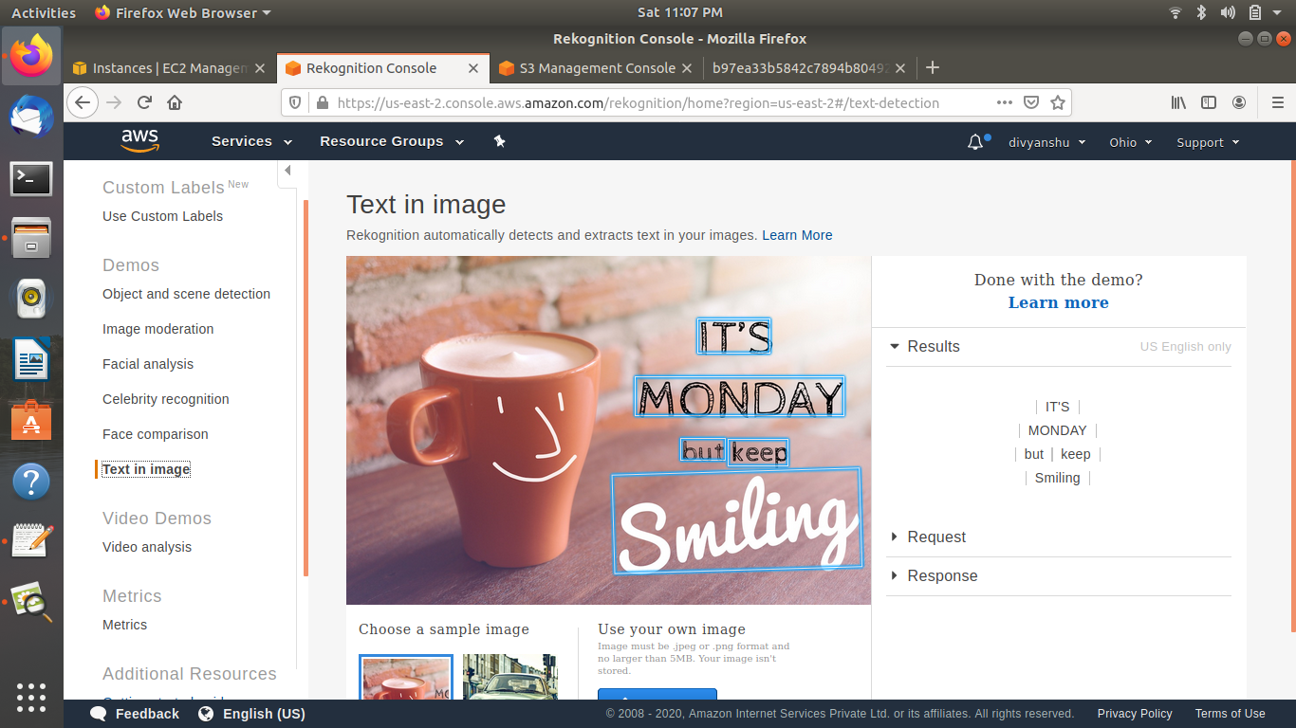

**EC2 & S3 ->**

1. Installing aws-sdk ->

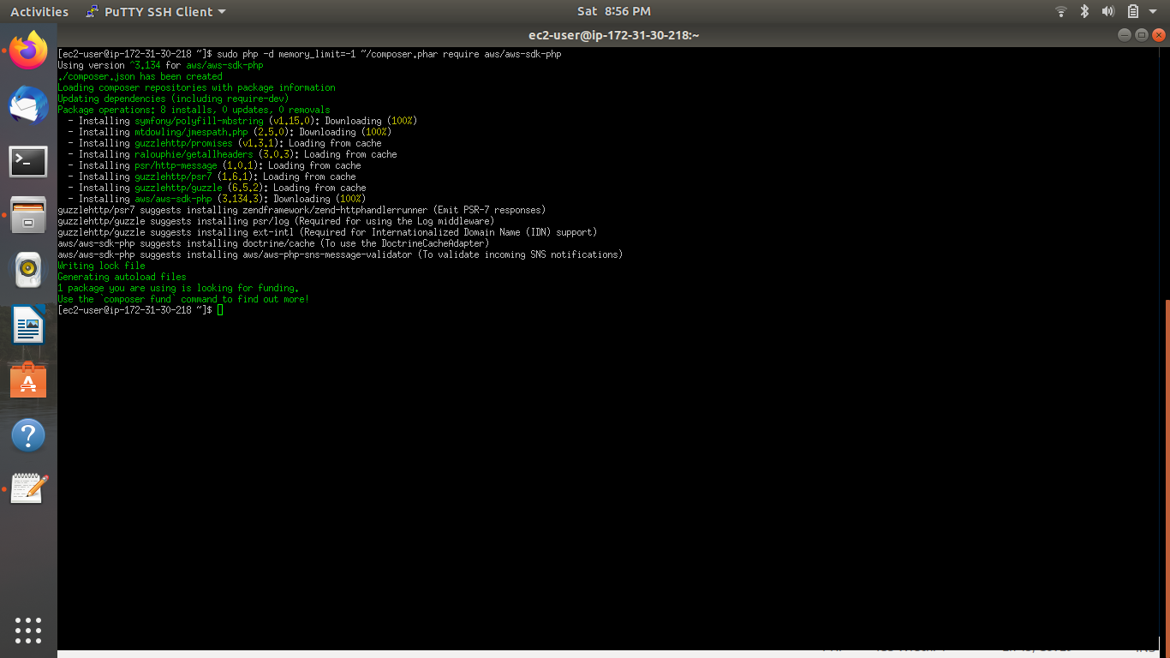

2. Installing php ->

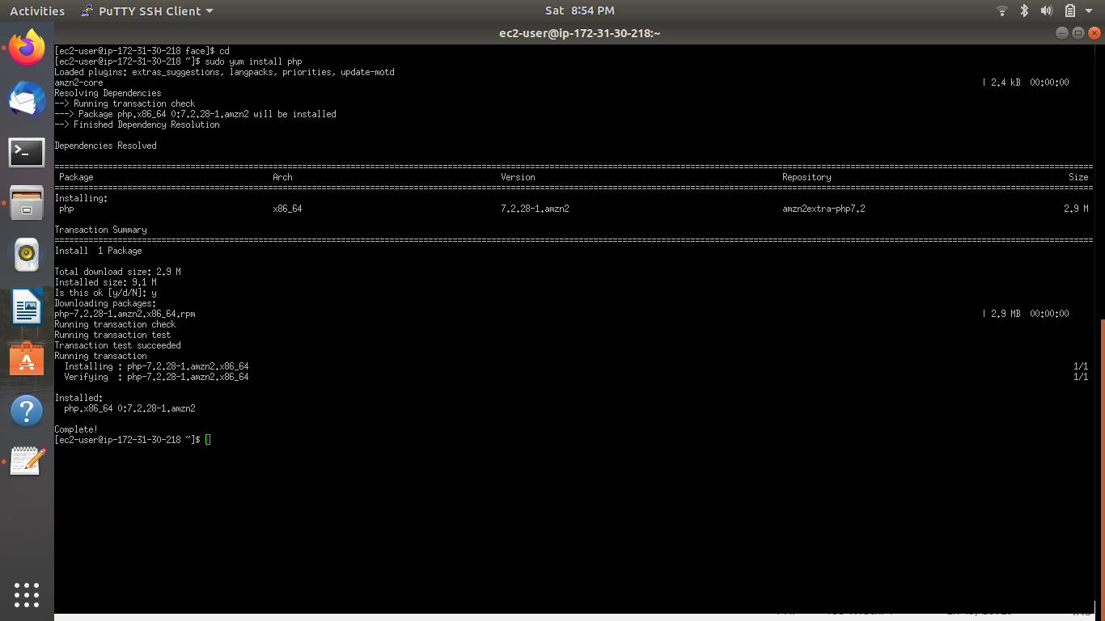

3. index.php file code ->

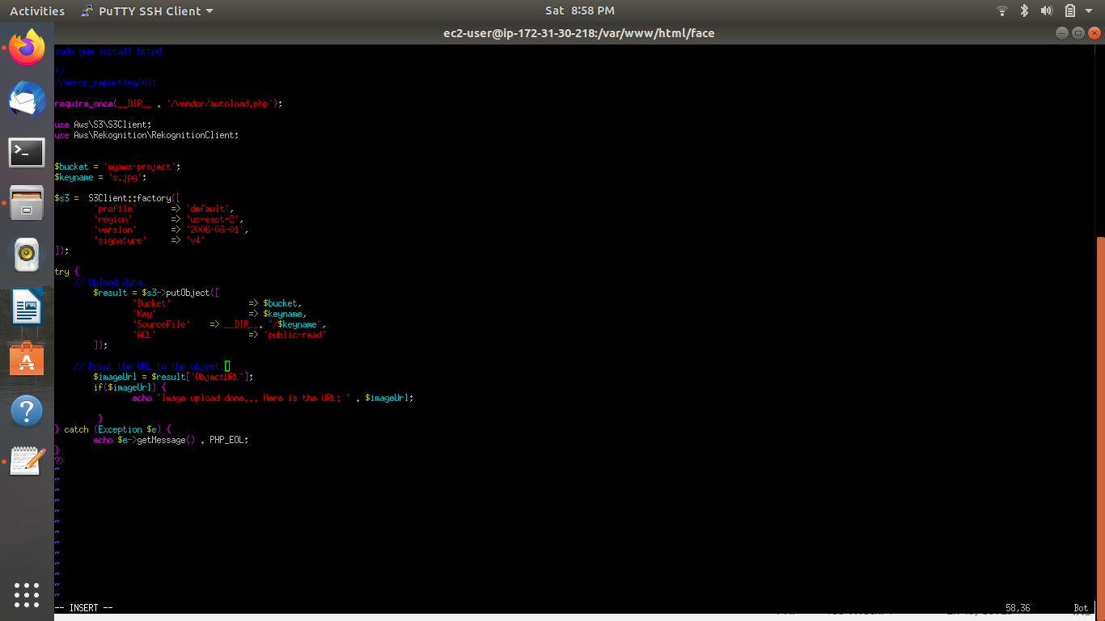

4. Upload success screenshot ->

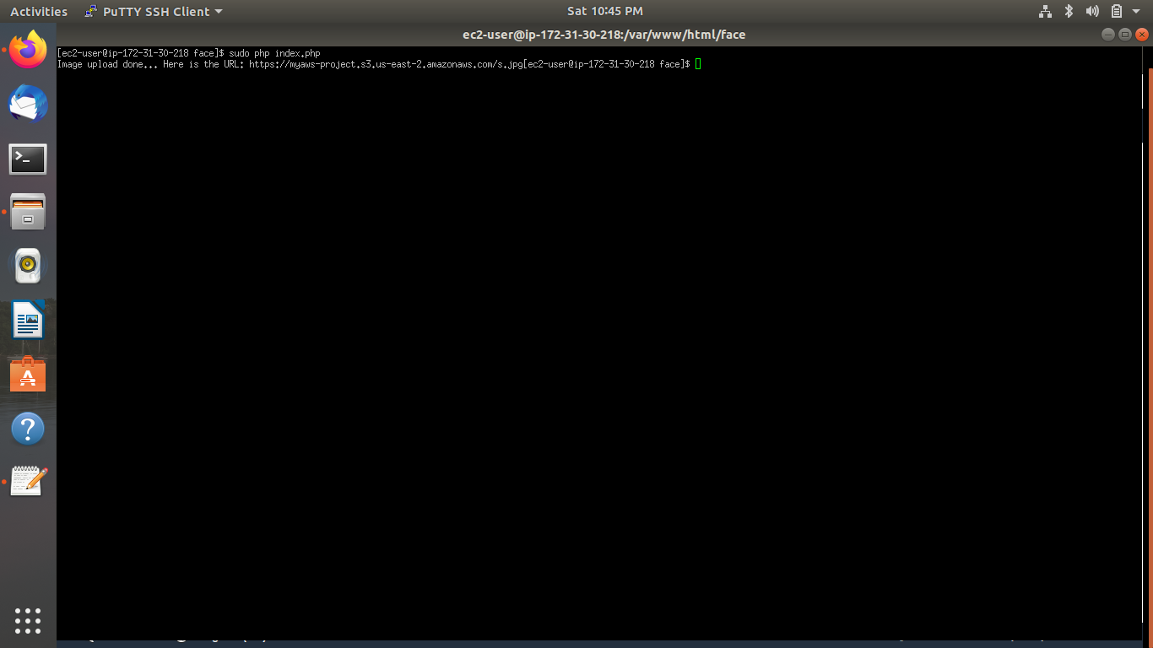

**EC2 & Rekognition ->**

1. Face Detect success screenshot ->

